MUDDA
END TERM VII SEMESTER SYNOPSIS REPORT
Submitted in partial fulfillment of the requirement of the degree of

BACHELORS OF TECHNOLOGY
to
The NorthCap University
by
Saumil Kulshreshtha(22CSU158), Shivesh Kumar Dhiman(22CSU164)
Shubh Pundir(22CSU165), Vikas Kumar(22CSU190)

Under the supervision of
Dr. Shilpa Mahajan
Faculty, Department of Computer Science and Engineering
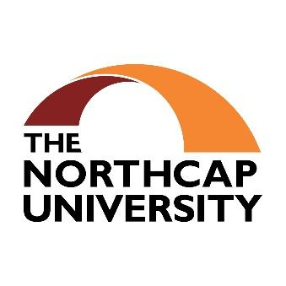
Department of Computer Science and Engineering
School of Engineering and Technology
The NorthCap University, Gurugram- 122001, India
Session 2025-26
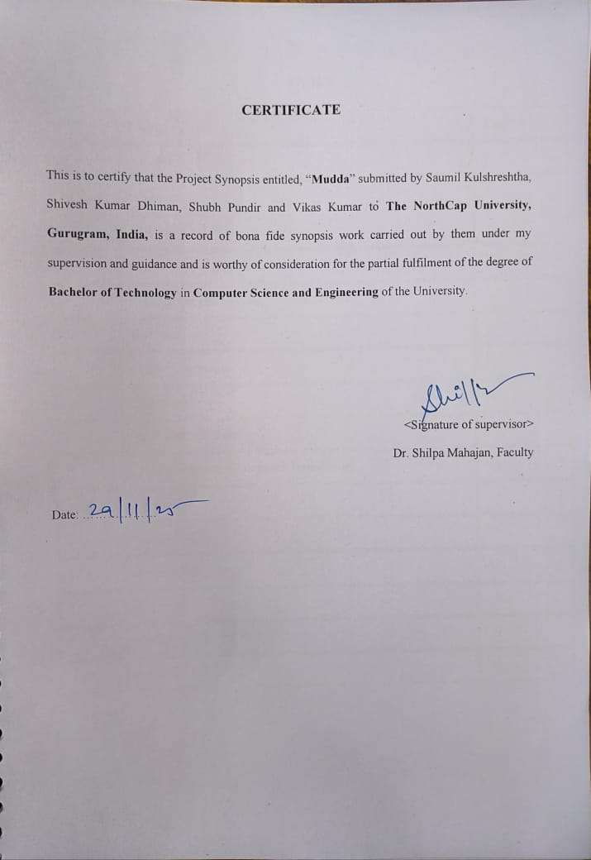
INDEX

S.No | Topic | Page No.
1. | Abstract | 1
2. | Introduction  2.a Background  2.b Feasibility Study | 2
3. | Study of Existing Solutions | 5
4. | Comparison with Existing Software Solutions | 6
5. | Gap Analysis | 8
6. | Problem Statement | 9
7. | Objectives | 10
8. | Tools/Platform Used | 11
9. | Design Methodology/Research Methodology | 13
10. | Outcomes | 14
11. | Gantt Chart | 16
12. | Responsibility Chart | 17
13. | References | 18
14. | GitHub and Drive Links | 19
15. | Annexure I | 20

- Abstract

The citizens of developing nations are faced with many types of civic issues (such as potholes, accumulating garbage, broken streetlights, water shortages, and poorly maintained public spaces). Grievance complaint systems that currently exist are often poorly organized, lack transparency, and are inefficient, meaning it takes a long time for the government to respond to a complaint and the public becomes dissatisfied. In general, when a citizen wants to lodge a complaint with the government, they must visit their local government office, call the office, or use state or municipal-level apps that are not comprehensive and have limited capabilities.

The idea behind this project is to create Mudda: a mobile application that functions like social media, designed to allow citizens to submit civic grievances in a much more modern way. With Mudda, citizens can publicly report on civic-related problems while providing a simple, transparent, and collaborative way for them to get their voices heard. The app provides features that allow citizens to report problems via video or photo, provide status updates in real-time, tag the location of the problem, find duplicates of the same issue via AI, and perform sentiment analysis of the reported issue. Citizens can comment on, upvote and share civic-related problems. In turn, this creates community engagement, and as a result, creates social accountability among citizens.

On the government side of the app, Mudda provides role-based dashboards for government officials ranging from the ward level, to city, to state, and to national levels of government to help them effectively manage and resolve reported issues. The app provides verified status updates on reported issues and completion of the problem's resolution, thereby increasing the transparency of the government's actions and fostering trust between the citizens and the government.

Mudda seeks to deploy an innovative technology model by combining the capabilities of newer technologies, such as machine learning and cloud computing, with an intuitive user experience (UX) to deliver an effective, scalable, and user-friendly solution that allows communities to address public infrastructure needs together. This will improve local governance and create an improved governance environment through the utilization of community involvement.

- Introduction

a. Background
Civic issues are common in many developing nations, which affect the daily lives of citizens. For example, potholes on the roads, garbage lying on the streets, streetlights that are broken, water shortages, and public spaces that are not well maintained. The past solutions to address civic issues have typically included submitting a complaint through the Government Office, calling a Government Helpline or through the Internet, but these solutions take time and are not always efficient or transparent. Citizens face challenges in tracking their complaint's progress, identifying the agency responsible for their complaint and knowing when or how their complaint will be resolved.
Digital platforms that were created to provide a better interface for citizens to interact with government agencies often do not have a good user experience for citizens, do not provide real-time updates and do not provide sufficient integration into the government's systems. This leads to an additional level of frustration for citizens, as well as a sense of detachment between citizens and government agencies.
Government agencies using these digital platforms also face similar problems to those of the citizens. They find it difficult to monitor the number of complaints submitted in any given period, prioritize the complaints appropriately and hold themselves accountable due to the same issues which caused the citizens to submit the complaints in the first place.
It has been noted that when a particular issue has gained attention and is widely recognized, the representative from the citizen would then take action to address the issues and inefficiencies in the civic system. This is the role of the political representative.
An active and engaged community allows for the collective voice of that community to raise awareness of the most critical issues facing its members, thereby utilizing the most powerful tool in a democratic system, The collective voice of the masses. Individuals within a community will then be able to hold their public officials accountable and demand that action is taken by their elected representatives.
Mudda is a proposed web-based platform that incorporates many elements of popular social media platforms, but with an emphasis on how citizens can publicly post civic issues generated from personal experiences and observations. Instead of filing complaints to an organization or elected representative privately, the Mudda message space allows users to post these issues for everyone to read. This new method of reporting civic issues allows for a greater sense of transparency and engagement for the community as a whole and affords the government and other organizations the opportunity to be more informed about the needs and wishes of citizens and therefore better prioritize the solutions to those issues.

b. Feasibility Study
The purpose of Mudda is to develop a scalable and implementable framework that will provide an avenue for citizens to communicate with Government officials and vice versa.
- Technical Feasibility:
In order to achieve this goal, Mudda will be created as a Mobile Application, which will have a powerful-server-technology option of Spring-boot (Java) and Flutter for both Android and iOS operating systems to enable a broader user base. We will use both PostgreSQL (relational) and MongoDB (non-relational database) systems to allow Mudda developers the ability to store both structured (metadata) and unstructured (Text) data. Furthermore, images of issues may also be uploaded to the database for ease of identification and classification. A location-based tagging of issues (using the location of the user when they submit their concern) will allow ease of tracking and categorization of issues reported to the Government. Also, Mudda will incorporate real-time status updates to enable stakeholders to see the latest update to the status of their report. Additionally, Mudda will incorporate a user authentication method for users to create, maintain, and manage their accounts, as well as the use of role-based access control for citizens and government officials. Further, Government efficiency can also be improved through the use of machine learning models that have previously been trained to automatically classify problems or find duplicate reports.
- Operational Feasibility:
The Mudda application is designed with a user-friendly interface so that every citizen can feel comfortable using it, including people who may not have any technical knowledge at all. Therefore, with the Mudda application in place, the operational barrier for the user to communicate their concern without the need to fill out a government form or search for a government representative has been removed.
- Feasibility Study:
Economic Feasibility - The use of cloud services, along with open-source technologies, will reduce the expenses associated with Mudda. To further cut down initial development expenses, the application architecture, as well as the development team being made up of students, is designed to have low infrastructure costs. Automation and digitization of grievance management will, in time, reduce the number of administrative overhead, which in turn, will increase overall efficiency at the local government level.
The overall conclusion from the feasibility study is that Mudda has proved to be a viable, cost-effective and valuable means of providing civic issue reporting and resolution to the citizens of our communities, therefore enabling enhanced local governance and increased citizen participation.

- Study of Existing Solutions

The current options of escalating civic grievance in India are very fragmented, with various platforms at different levels.
- National Government Platforms: At the Federal level, many tools are centered around particular concerns (for example Swachhata MoHUA deals with sanitation [1]), while some serve as "umbrella" portals for many of the various services provided by the government (for instance, UMANG) [7]), but none have been developed with the objective of local civic complaints.
- State and City Level Apps: PuraSeva (Andhra Pradesh) [2], and MCD311 (Delhi) [6], have a more comprehensive range of functions but are confined geographically when it comes to dealing with complaints. Other applications serve a very particular purpose, like water utility complaint systems (BWSSB MyComplaint) [4] and app for particular issues like Street Light complaints (GNIDA Street Light App) [3].
- Community Led Platforms: Community driven platforms, such as the two Citizen Driven platforms (ICRF) [5] and (NetaG) [8], where the aim is to bridge the gap between the citizen and the government official or elected representative and support civic engagement. However, it has been noted that these initiatives normally do not have government backing, and thus it relies on political goodwill or pressure from the media to achieve success.

- Comparison with existing software solutions

In comparison to currently available applications, The Mudda mobile application includes numerous distinct features that support more thorough impact and engagement opportunities. Today's contemporary applications provide limited ability to report incidents through text messaging/photo upload only, with minimal status updates on filed reports. The Mudda application will allow users to comprehensively track their incidents through several defined stages, in conjunction with date/time tracking of the incident. The Mudda application will include a hyperlocal social component that provides users with the opportunity to engage with their community by upvoting/adding comments/sharing information about their incidents. This additional feature transforms Mudda from a simple complaints management system into a community-based forum where community members come together to report and discuss incidents that impact them. The Mudda application will also include several new features powered by AI, e.g., duplicate report detection and sentiment scoring, which are not included in the current solutions available. Additionally, Mudda has plans to scale nationally, and to include role-based dashboards for local officials, at the ward, city, state, and national levels, which will significantly improve over today's applications that are limited to city-based or state-based functionality.
Feature Dimension | Swachhata-MoHUA | PuraSeva (AP) | MCD311 (Delhi) | CitizenCOP | ICRF | NetaG | Mudda (Proposed)
Scope | Sanitation only | State-level, multiple services | City-level civic issues | Safety + police + civic | Petition platform | Politician linkage | Pan-India, multi-sector
Issue Reporting | Text + photo + geo-tag | Text + photo + geo-tag | Text + photo + geo-tag | Text + photo | Petition posts | Text/photo | Text, image, video, geo-tag, categorization
Status Tracking | Limited updates, re-open option | SLA timelines, escalation | Basic status update | Police follow-up only | None | Politician-dependent | Detailed multi-stage (Pending → Resolved) + Time Tracker
Community Engagement | None | None | None | None | Public support via signatures | Limited to feedback | Upvotes, comments, duplicate detection, misinformation filter
Government Integration | Direct sanitation departments | Full ULB integration | MCD officials | Police only | Not official | Informal political channel | Role-based dashboards (ward, city, state, national)
Analytics for Officials | None | Heatmaps, reports | Limited internal use | None | None | None | Comprehensive dashboard: hotspots, recurring issues, avg. resolution time
Awareness Tools | None | None | None | None | SMS alerts | Politician engagement | Map-based issue visualization, geofencing alerts, multilingual posts
Transparency | Re-open complaints | SLA timelines | Limited | Limited | None | Dependent on politician | Blockchain audit trail (optional), area-wise metrics
Scalability | National but narrow | State-specific | City-limited | Multi-city, police only | National but unofficial | City-limited | Nationwide scalability with local → state → national categorization
Trust & Verification | OTP login | Aadhaar/OTP | OTP | OTP | No checks | None | Verified govt accounts, OAuth users, abuse reporting
Social Layer | None | None | None | None | Support votes | Politician replies | Friends list, messaging, sharing → true “social media” for civic issues
Smart Intelligence | None | None | None | None | None | None | AI-based duplicate detection, sentiment urgency scoring, misinformation filters

- Gap Analysis

The analysis indicates many significant components of traditional civic-tech tools that mudda plans to address.
- No Political Incentivization: Typical current civic-tech solutions do not effectively include elected officials who are motivated to deal with public visibility. Based on this gap, Mudda's design is intended to bring "high-traction" issues to the attention of local politicians to encourage quicker resolutions.
- Low Community Engagement: Most civic-tech solutions are simply transactional "complaint box" systems. They do not provide a social layer for individuals to discuss, vote on, or elevate their issues leading to low adoption and engagement by users.
- Limited Scope and Scalability: Current civic-tech solutions are generally limited to one city, state, or specific issue (i.e., sanitation, water). No platform has been developed with a view toward being scalable nationwide while maintaining hyper-local relevance.
- No Use of Smart Technology: Current civic-tech applications do not leverage AI or any smart technology, making it difficult for local officials to triage complaints based on the severity of complaint and public sentiment.
- Low Transparency and Trust: Many users (citizens) do not know what happens after submitting their complaints and do not feel confident in the complaint-handling process due to a lack of transparency and lack of follow-up enforcement. Mudda is proposing that verified government accounts will help improve trust in the processes.

6. Problem Statement

The overwhelming majority of people in developing nations are experiencing various civic challenges such as: potholes; waterlogging; broken lights; garbage build-up; lack of access to safe drinking water; poorly-maintained public places. Citizens today do not have the access they need to properly report these issues to local and state governments. Reporting methods today include: going to governmental offices; calling the local government; and submitting complaints through multiple online portals which do not communicate with one another. So, by the time citizens finally have their issue addressed, they have wasted time and money on bureaucracy.
Citizens cannot track the progress of their complaints. Citizens are often unaware of the identity of the responsible governmental authority. Citizens cannot see how many complaints have been issued about the same issue as their own in their respective jurisdictions.
Local and state governments do not have efficient systems in place to prioritize and resolve a high volume of public complaints due to a lack of comprehensive governance and a lack of centralized systems that centralize all information and provide governmental authorities with structured and real-time data.

The result of this disconnect is:
- a high level of non-responsiveness on the part of government officials to the public
- a lack of accountability of government officials
- a lack of transparency of the governmental grievance redressal process
- a high level of frustration and loss of trust by citizens towards government officials
- inefficient use of limited government resources in addressing public problems.

Digital solutions are available today to assist in reporting civic problems. However, most of these solutions do not have user-friendly interfaces, do not allow users to track the progress of their complaints in real time, and do not provide integration with governmental work systems, therefore leading to minimal adoption and minimal success in resolving the issues of citizens.

7. Objectives

The Mudda project aims to establish a user-friendly platform for reporting and addressing civic concern to promote engagement and communication between residents and local governments. This can be accomplished by:
- Creating Easy Access to Reporting Problems:
Developing a mobile application that enables residents to report concerns including potholes, flooding, damaged street lights, trash, etc., without needing to understand how to file formal complaints.
- Increasing Transparency & Accountability:
Providing residents with real-time access to the status of their reported concerns, the assigned department to resolve the concern, and any follow-up required will instill confidence in government operations and improve the feeling of responsibility among government agencies.
- Increasing Efficiency in Government Response:
Providing a unified digital platform for government officials to manage, rank, and provide a resolution to reported concerns will allow for improved efficiency. The structured data, location tags and dashboards will enable better tracking of ongoing concerns.
- Fostering Community Involvement:
Allowing residents to see, comment and endorse (by liking/up-voting) problems reported by other residents will create an opportunity for residents to become more educated about problems within their community and will create greater collective pressure on local governments to address problems.
- Issue tracking based on geographic location:
Geographic location tracking through geotagging should enable users to precisely identify the geographic location of various issues. By visualizing this information on a map, authorities can use this data to prioritize issues based on the severity of the issue and their location.
- Support media reports:
Users should be allowed to submit photos with their posts to provide visual confirmation for authorities to improve the quality of the user complaints.
- Create a notification system:
The notification system is designed to provide citizens with timely updates regarding the status of the raised issue, the progress the government has made on the raised issue and any other recent developments. This is done to create timely communication between citizens and government.

8. Tools/platform Used

The process of developing Mudda entailed using a contemporary technology stack designed for mobile-centric civic engagement platforms; specifically, this included the following major components:
1. Front-End Development:
- Flutter Framework - Utilized to design a cross-platform mobile application that would present the same user interface on Android as well as iOS devices.
- Android Studio and Visual Studio Code - Both Integrated Development Environments used to develop the user interface, organize the project's structure, debug, and test the application on emulators.
- Next JS - Web + Mobile based browser dashboard for admin login and to see issue status, analytics, workflow and human in the loop integration for automatic issue resolution. The dashboard also includes visualization of workflow orchestration.
2. Back-End Development:
- Spring Boot (Java) - Provides the ability to create highly secure, very modularized, and highly efficient REST-Based Application Programming Interfaces for all aspects of managing issues, authenticating users, media handling and role based dashboards for users.
- Python - Automatic AI Workflow microservice + Model Training and development for issue duplication, hate speech recognition, AQI Assessment, etc. AI Workflow service is a smart agentic AI system with built in workflow orchestration that automatically makes a plan for a said issue and autonomously calls the other microservices/API endpoints to carry out plans accordingly.
- Visual Studio Code - Utilized as the primary development environment for creating code and for testing and integrating all code developed for the back-end.
3. Databases:
- PostgreSQL (AT Neon) - Acts as the primary data repository, providing a relational database structure for all other entities within the system including users, government roles, issues and tracking.
4. Cloud and Deployment:
- Amazon Web Services (AWS) - Provides the capabilities to host the back-end application, scale and make the application highly available and deliver secure APIs to the front-end via AWS.
5. DevOps and Version Control:
- GitHub - Provides the tools needed to manage source code, work collaboratively with others, branch source code, and to perform code reviews.
- GitHub Actions (CI/CD) - Provides a mechanism for creating automated build and deployment pipelines, thereby enhancing productivity and streamlining software development and releases.
6. Documentation and Team Coordination
- The team uses Notion as the primary tool for documenting project information (e.g. Project Meeting minutes, tasks, Planning resource) because there is no official Project Management Tool available for the project.

9. Design Methodology/Research Methodology

The Mudda project utilized an Agile Software Development Methodology which focused on ongoing improvement, flexibility, and continuity of development through iterative development cycles.
1. Iterative Development
Development occurred in short development cycles (sprints). At each end of each sprint functional components (e.g., logging in, posting issues, viewing dashboards) were completed, tested and assessed.
2. Continuous Feedback
Frequent team discussions allowed quick feedback on newly developed features, thereby enabling team members to enhance user interface design elements, streamline back-end processes and optimize API integration through practical testing rather than having to wait until the end of development.
3. Concurrent Workstreams
Agile’s ability to have the Front End, Back End and DevOps teams work in parallel greatly reduced the overall development time while eliminating bottlenecks.
- Front End – Developed and tested user interface screens.
- Back End – Built APIs and database schemas.
- DevOps – Built deployment pipelines and set up environments.
4. Incremental Feature Addition
Key features such as creating a new issue, uploading images, displaying government dashboards, authenticating users, and sending notifications were added sequentially over a period of time rather than being released simultaneously. Each feature was integrated incrementally into the existing system and extensively tested.
5. Design Flexibility
Because of iterative development processes, the Agile framework allowed for flexibility as the project progressed. Examples of design flexibility include enhancing the issue tracking process, adding sentiment based prioritization, and streamlining role based access.

10. Outcomes

It is anticipated that as a result of the adoption of the Mudda application, numerous benefits will be reaped from the system:
- Efficient Issue Reporting Process:
Citizens will no longer require going into the office, utilizing the telephone or going through many bureaucratic steps to report a civic problem because they can do so through their smartphones in the time it takes to check Facebook.
- Improved Transparency:
Users will have the ability to view the real-time status of their reported issues, along with who is working on them (government authority), and also be able to view the number of similar issues that have been raised in their locality by others, which will help to increase the level of trust in the grievance redressal system.
- Faster Issue Resolution:
With an online access to all problems and issues reported to the government, government officials will have a dashboard that will allow them to view and categorize all issues into one place and quickly assess and resolve public issues.
- Enhanced Citizen Engagement:
Because the Mudda application has a social media-like format, it will engage more citizens in the posting of issues, liking, commenting on and sharing issues, which will in turn raise public interest and involvement in the local government.
- Data-Driven Governance:
Government authorities will be able to utilize the trends in data (for example: how many issues have been reported in each region, the type of problem being reported, the frequency of reporting) to make decisions based on evidence and allocate government resources more effectively and to make improvements on a more permanent basis.
- Visual Documentation of Problems:
The availability of photographic or video evidence for all issues submitted will greatly reduce the uncertainty surrounding the assessment of an issue by the relevant authority through enhanced understanding and reduced mis-interpretation.
- Accountability of Authorities Increased:
With real time tracking of complaints; public visibility of complaints and status updates; the degree to which authorities are held accountable and are responsible for resolving issues will significantly increase.
- Monitoring by Communities:
Communities can monitor community issues, upvote issues of greatest concern to them, and see other communities face similar concerns.
- Scalable System:
Mudda will be developed on a highly scalable application; thus, enabling other future enhancements i.e., automating classification of issues, detecting duplicate instances of issues, implementing multi-lingual capabilities.

In summary, Mudda is committed to changing the existing slow, non-transparent and non-participative system of community reporting of civic-related issues into an efficient, transparent and participative digital reporting service that is community-centric.

11. Gantt chart

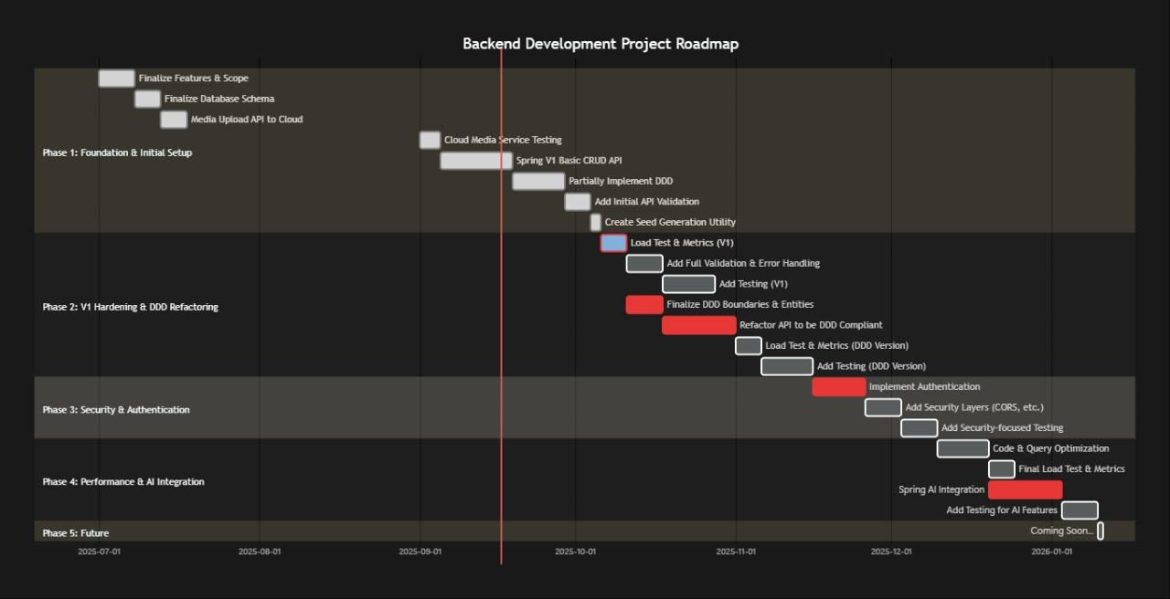

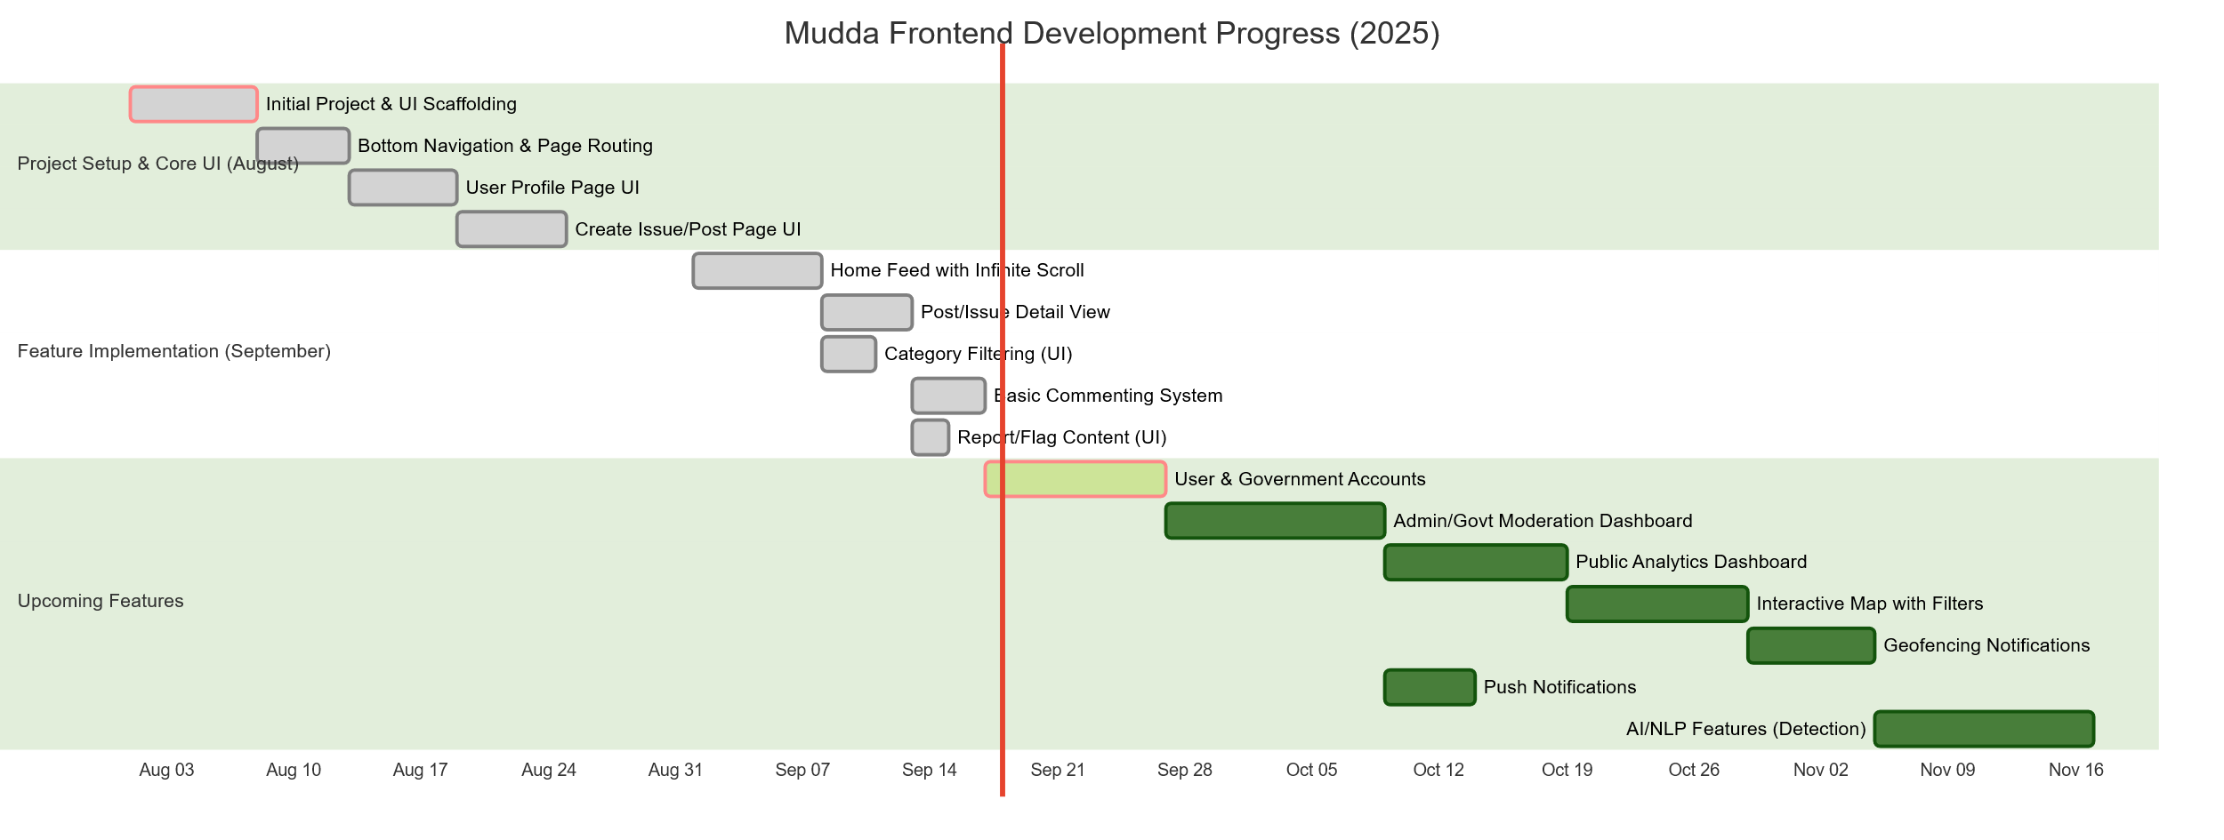

12. Responsibility chart

Team Member | Role | Responsibilities
Saumil Kulshreshtha | Frontend Lead | • Designing and developing the user interface of the mobile application using Flutter  • Ensuring a user-friendly and intuitive experience for issue posting and tracking  • Implementing media upload features.  • Coordinating with Backend and DevOps teams to integrate frontend with APIs
Shivesh Kumar Dhiman | DevOps/ Frontend | • Assisting in frontend development tasks  • Managing application deployment pipelines (CI/CD)  • Setting up and maintaining development, testing, and production environments  • Configuring and managing cloud infrastructure.  • Ensuring proper cloud resource allocation, scalability, and reliability
Shubh Pundir | AI Models/ Backend | • Implementing AI functionalities (e.g., automatic issue categorization, duplicate detection)  • Developing backend APIs using Spring Boot for issue management  • Integrating machine learning models with the backend  • Handling data preprocessing and model inference services
Vikas Kumar | Backend Lead | • Leading the backend development team  • Designing and implementing the database schema using PostgreSQL and MongoDB  • Creating secure and efficient REST APIs for issue posting, tracking, and user management  • Ensuring scalability and performance of the backend system

13. References
[1] MoHUA, G. (n.d.). Welcome to the SWACHHATA platform. Swachh Bharat. https://www.swachh.city/
[2] Gov Of AP. (n.d.). Commissioner & director of Municipal Administration government of Andhra pradesh. PURASEVA | Commissioner and Director of Municipal Administration. https://cdma.ap.gov.in/en/puraseva-3
[3] Greater New Okhla Industrial Development Authority. (n.d.). Gnida Street light app. Google. https://play.google.com/store/apps/details?id=gnida.street.gnidastreetlightapp&amp%3Bhl=en_US
[4] Home - bangalore water supply and Sewerage Board. (n.d.). https://bwssb.karnataka.gov.in/english
[5] JobX Robot Pvt. Ltd. (n.d.). ICRF App. ICRF. https://www.icrf.org.in/index.html
[6] MCD. (n.d.). MCD 311 App. https://mcdonline.nic.in/portal
[7] MeitY. (n.d.). Umang App India. UMANG. https://web.umang.gov.in/
[8] NetaG app(Unpublished app). NetaG. (n.d.). https://www.appbrain.com/app/netag/com.netag

14. GitHub and Drive Links

Backend repository: https://github.com/Cipher3003/Mudda.git
Frontend repository: https://github.com/DivSaumil/mudda_frontend.git
AI-Workflow repository: https://github.com/ShubhPundir/Mudda-AI-Workflow.git
Hate speech detection model: https://drive.google.com/drive/folders/1y5NoTcsKrmVWkNrMalTdIlpHEr_8Sc80?usp=drive_link
Computer vision detection model: https://drive.google.com/drive/folders/1pvOTghK6L6ZJfwsZ4JLQyoMEgiXoZtmg?usp=drive_link

15. Annexure I

